**LETSUPGRADE LINUX ADMINSTRATION**

**ASSIGNMENT DAY 5**

**1. Add a 10GB disk to the CentOS.**

Verify That Disk Is Added Using **fdisk -l**

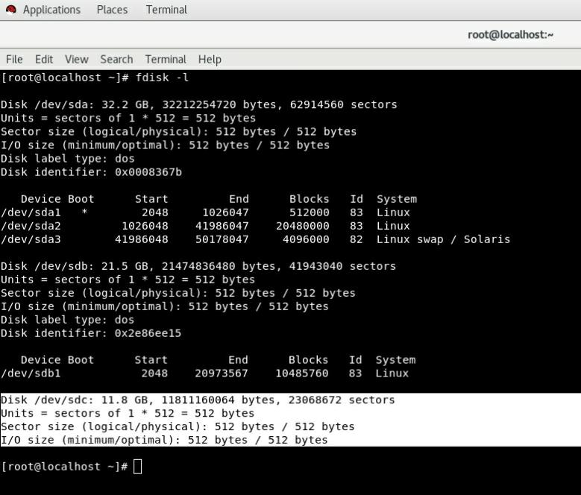

**#I Have Taken 11Gb To Avoid Any Kind of Storage Issue.**

**2. Create 2 Partitions 4GB and 6GB of Space respectively.**

Creating 2 Partitions

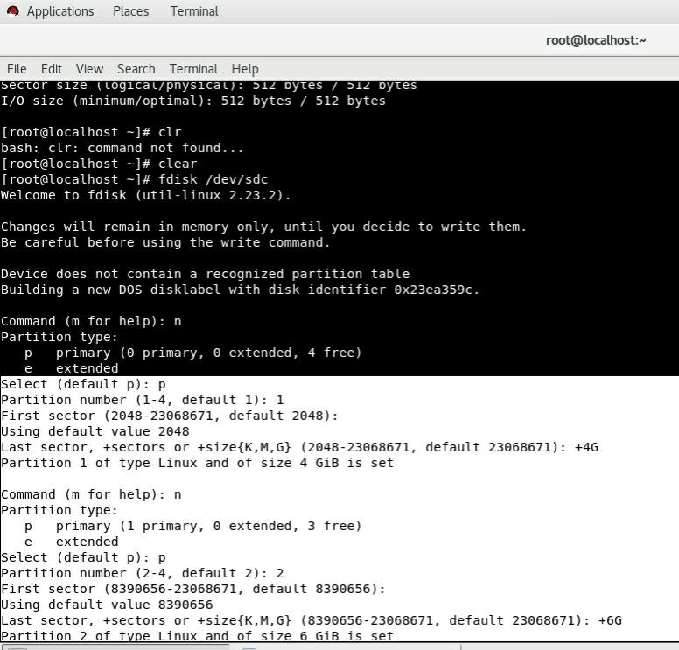

**3. Format 4GB with xfs and 6GB with ext4 file system.**

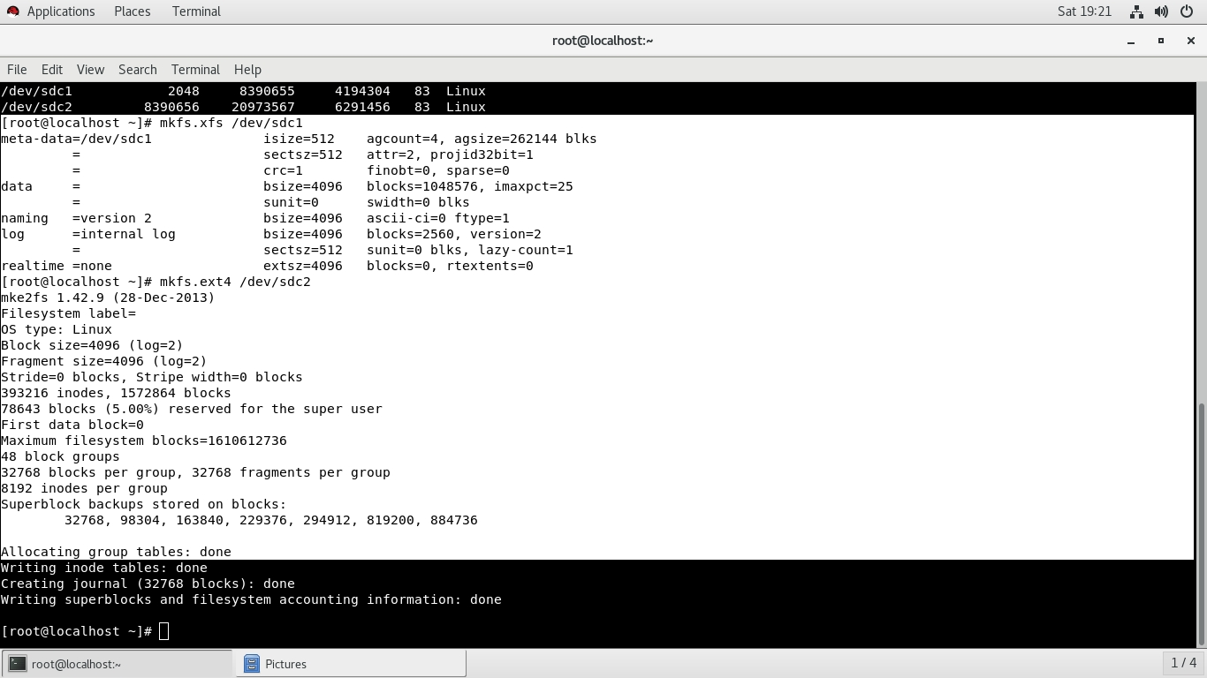Formatting and Creating File System Using **mkfs** Command

**4. Mount 4GB and 6GB in /data and /music directory respectively.**

Creating Mount Point Using **fstab** File

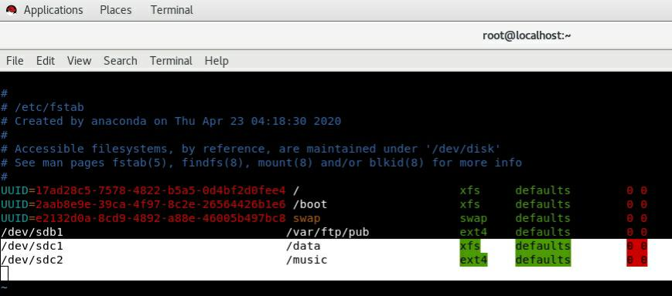

**Verifying Mount Point Is Created**

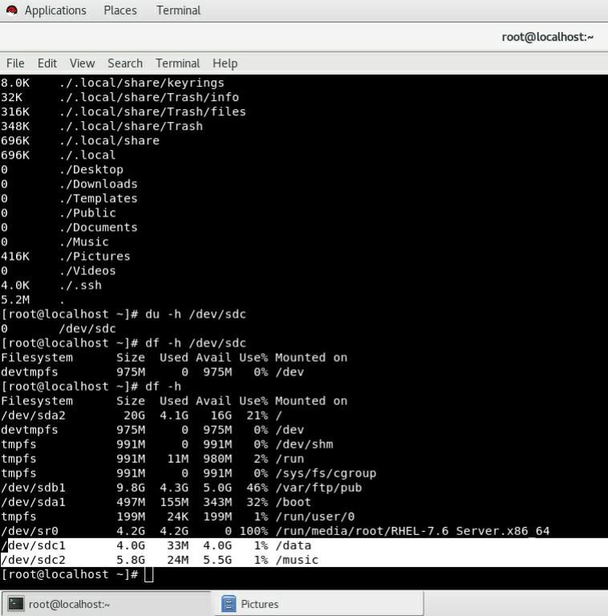

**5. Create one file of 1GB in each of the mount point created above.**

Creating 1Gb File Using **seq > 1000000** Command

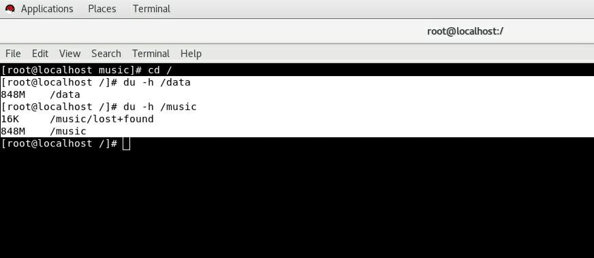

**#Here the File Created Is Having 848 Mb Which Is Closest To 1Gb**

**6. Verify the disk Consumption and disk space free in the mounted partitions.**

Verify Disk Usage Using **df -h** Command

